Name:___________________________ Lab Section:_________
GGIS 103 Lab Assignment 1: Introduction

Goal: Over the course of this lab, assignments will frequently involve utilizing maps to examine, identify, and describe physical geographic features. As there is no GIS prerequisite for this course, we will instead utilize Google Earth for assignments. This lab will introduce a few skills in Google Earth needed for future labs. It will also cover some other basic map reading skills.
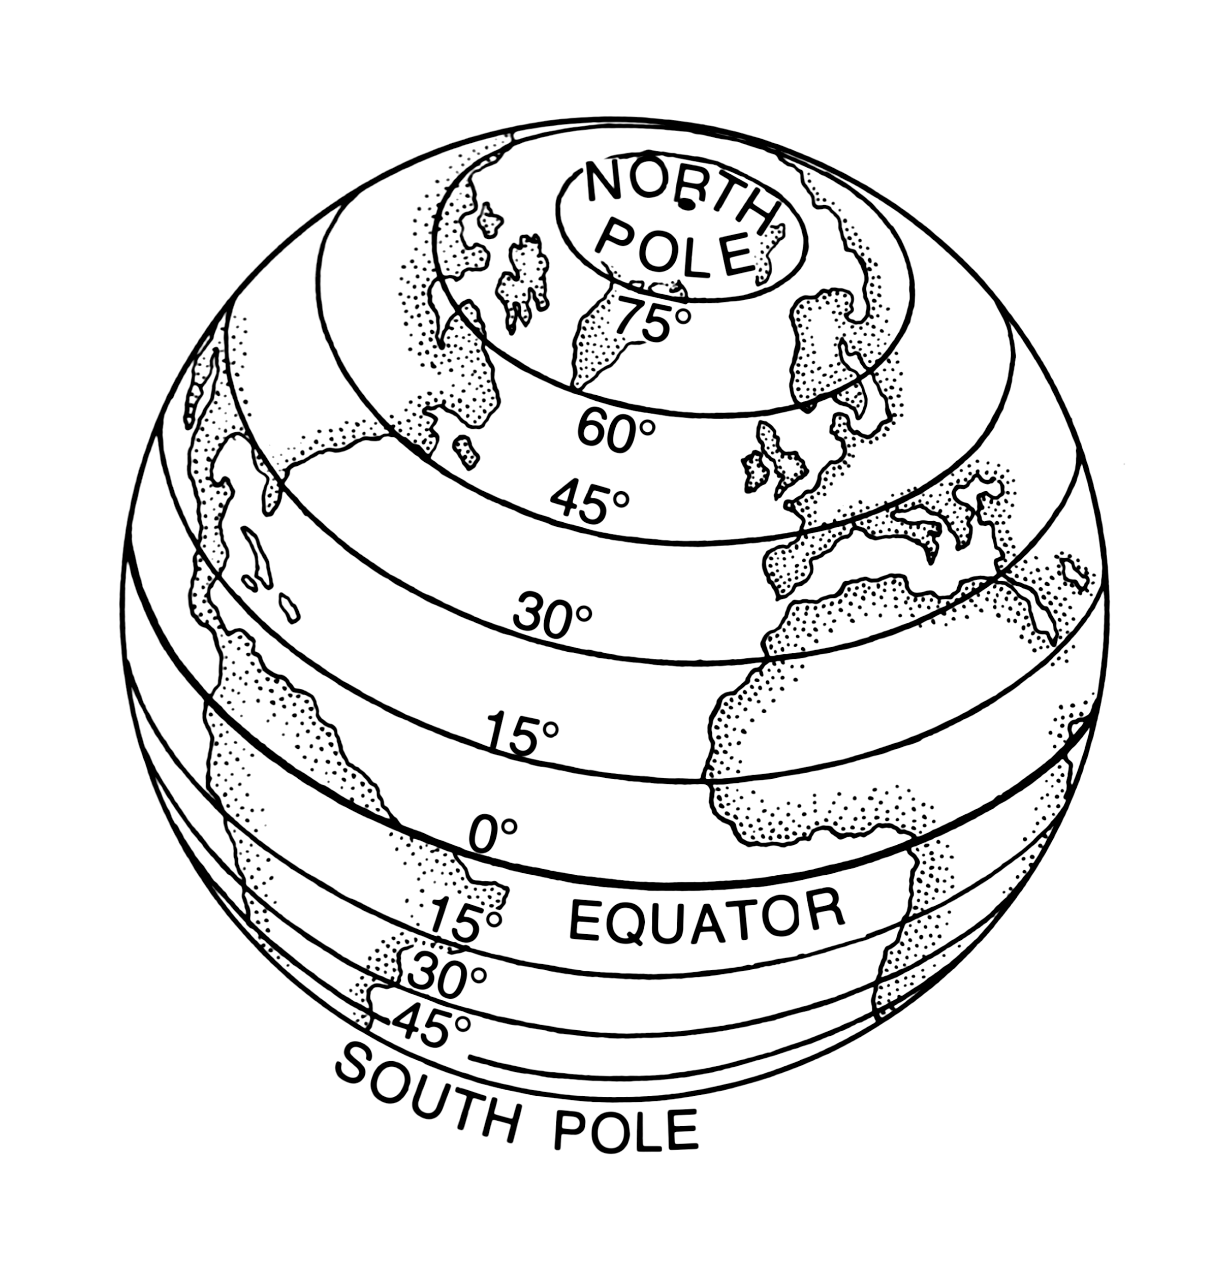
Part 1: Maps

Latitude (parallels)
- Angular distance North or South of equator measured in degrees (0-90°)
- Runs East-West, but measures North-South from equator to poles
- Each degree can be divided into minutes (‘) and seconds (“)
- 60 min = 1 degree Latitude
- Must specify degrees N or degrees S to know which hemisphere you are in
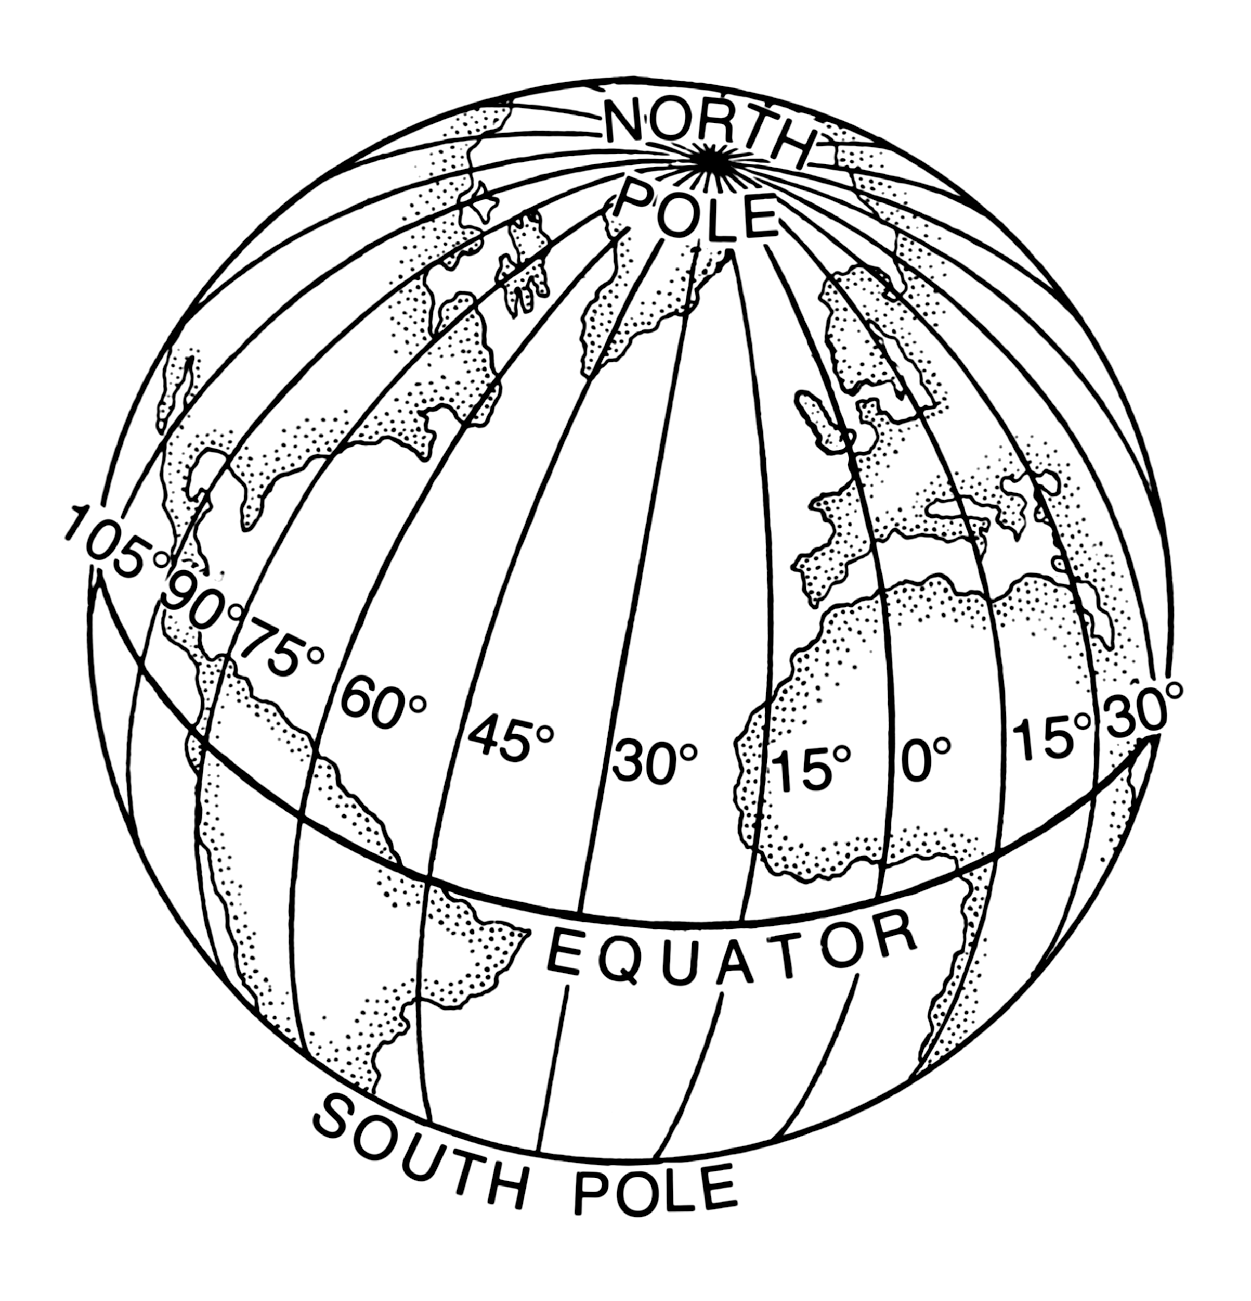
Longitude (meridians)
- Angular distance East or West measured in degrees (0-180°)
- Must specify degrees E or degrees W to know which hemisphere you are in
- Runs North-South, but measure East-West from the Prime Meridian (0°) to the International Date Line (180°)
- Each meridian is the same distance around, meeting at the poles

Topographic Maps
- Contour lines describe terrain
  - They connect all the lines that share the same elevation
  - The closer together the lines are, the steeper the terrain
- Every fifth line is an index contour line which will list its exact elevation
- The contour interval is the change in elevation from one line to the next. It varies map to map.
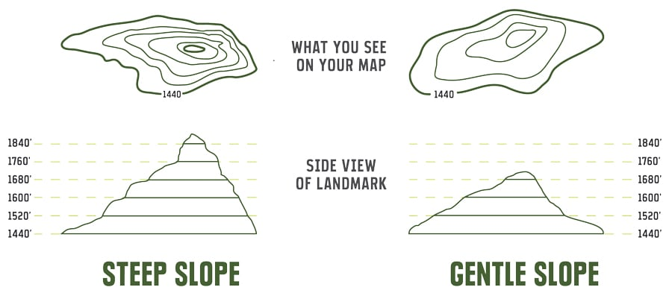
- If the contour lines indicate a depression, rather than a peak, the lines will have tick marks

Questions:
1. If I asked you to look up a location at 40.1164°, 88.2434° could you find it? Why or why not?

2. Lines of _______________ run perpendicular to the equator and converge at the poles and lines of _______________ run parallel to the equator.

Look at the section of topographic map. This is just south of Urbana.
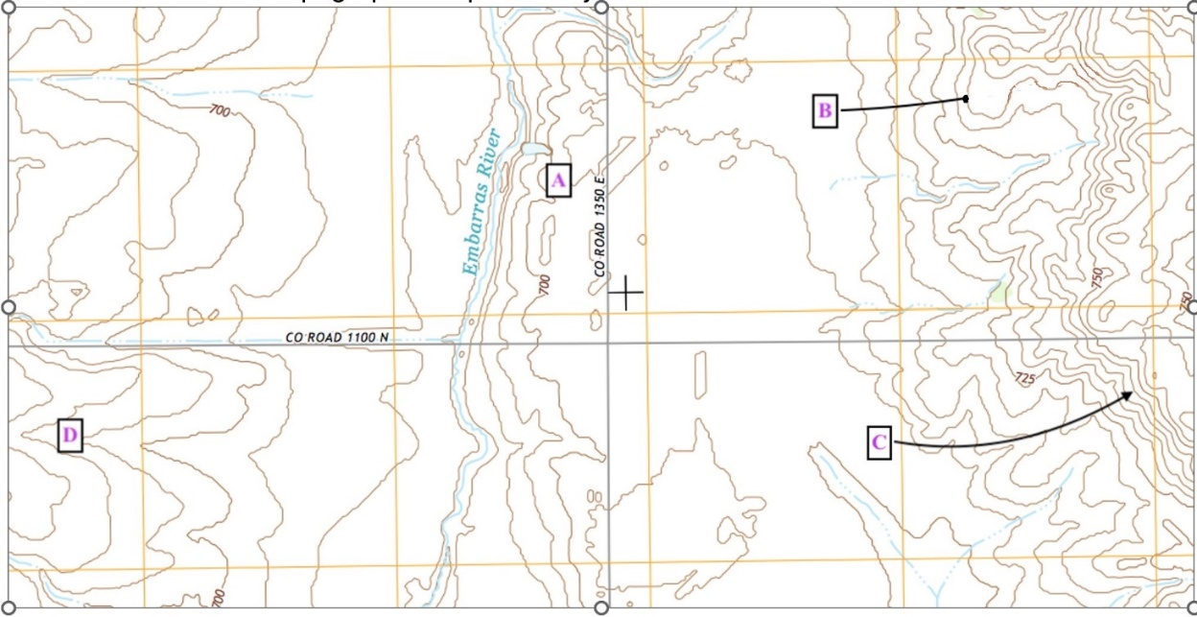

3. What is the contour interval (elevation difference between each line)?subst

4. What are the highest and lowest elevations?

5. Where is the steepest slope? (A, B, C or D?)

Part 2: Google Earth Introduction

- Download Google Earth Pro. If you know how to use Google Earth Chrome, including importing .kml and .kmz files, and you prefer it over the standalone application, you can use it instead. Please inform me if you choose to complete the lab with Google Earth Chrome. Assignment Instructions for this lab will only be applicable to Google Earth Pro (desktop version).
- Open Google Earth Pro.
- Under the Layers menu on the left hand of the screen, enable “Places” and “Terrain,” and disable all other layers.
  - Typically, when many layers are enabled, the map can become very cluttered, and the application may run more slowly.
- Make sure map units are in ft/miles. (Tools -> Options -> Feet, Miles -> OK) (or “Google Earth -> Preferences” on the Mac)
- Download the .kml file called “Lab 1 File” from the Canvas Week 2 Module
- You can open the .kml file in 2 ways:
  - In Google Earth, click File -> Import, then locate the .kml file that you just downloaded off Canvas. If you do not see the .kml file, make sure that the file extension window in the bottom right of the window is set to “All files”.
  - Or you can simply double click on the .kml file that you just downloaded. This will directly take you to Google Earth.
- After opening the file (make sure under “Places” menu on the left hand of the screen, “Lab Assignment 1” file is checked; you can also expand the “Lab Assignment 1” by clicking on the disclosure widget/triangle; now you will see 2 kml files under this: Paths1 and Points 1), answer the questions below.
_____________________________________________________________________

- Using the ruler tool (look for it at the top of the screen), measure a line from the east end of the path (near Jenny Lake, WY) to the west end of the path (near Alta, WY). Make sure the ruler is set to “Line”. How long, in miles, is the line?

- Use the ruler tool again, but this time set it to “Path” and follow the bends of the orange path. How long, in miles, is the path?

- With the Ruler Path that you created for question 2 still up, check the box “Show Elevation Profile”.

- Take a screenshot (or draw (approximately) if you are doing the assignment on a paper copy) of the elevation of the path and put it in the box below and make sure it has the horizontal and vertical elevation values along tick marks.

Alta, WY I | I Jenny Lake, WY

- What is the elevation gain and elevation loss across the path, as indicated above the elevation profile?

- Hover curser over the 3 blue markers to determine peak name. Use the 3D control arrows (next to the north indicator) to view the points in 3D. Which peak has the highest elevation (1, 2 or 3)? Which of the three peaks has the lowest elevation (1, 2 or 3)?
(tip: you can use SHIFT key + left/right/up/down arrow keys to rotate/move the view to better visualize the peaks!)

- Using major riverways (use the Missouri and Mississippi Rivers) and the ruler tool, trace a path from Kansas City, MO, to Davenport, IA. How long is this path (in miles)? Turn on the ‘Water Body Outlines’ for this (Layer<More< Water Body Outlines).
(tips: type ‘Kansas City, MO’ and ‘Jefferson City, MO’ in the search box and put a placemark 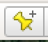 on each of the places. It will be easier to track the path)

